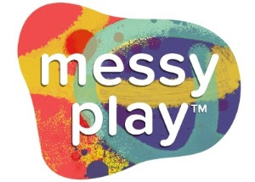

Let's Celebrate Love!
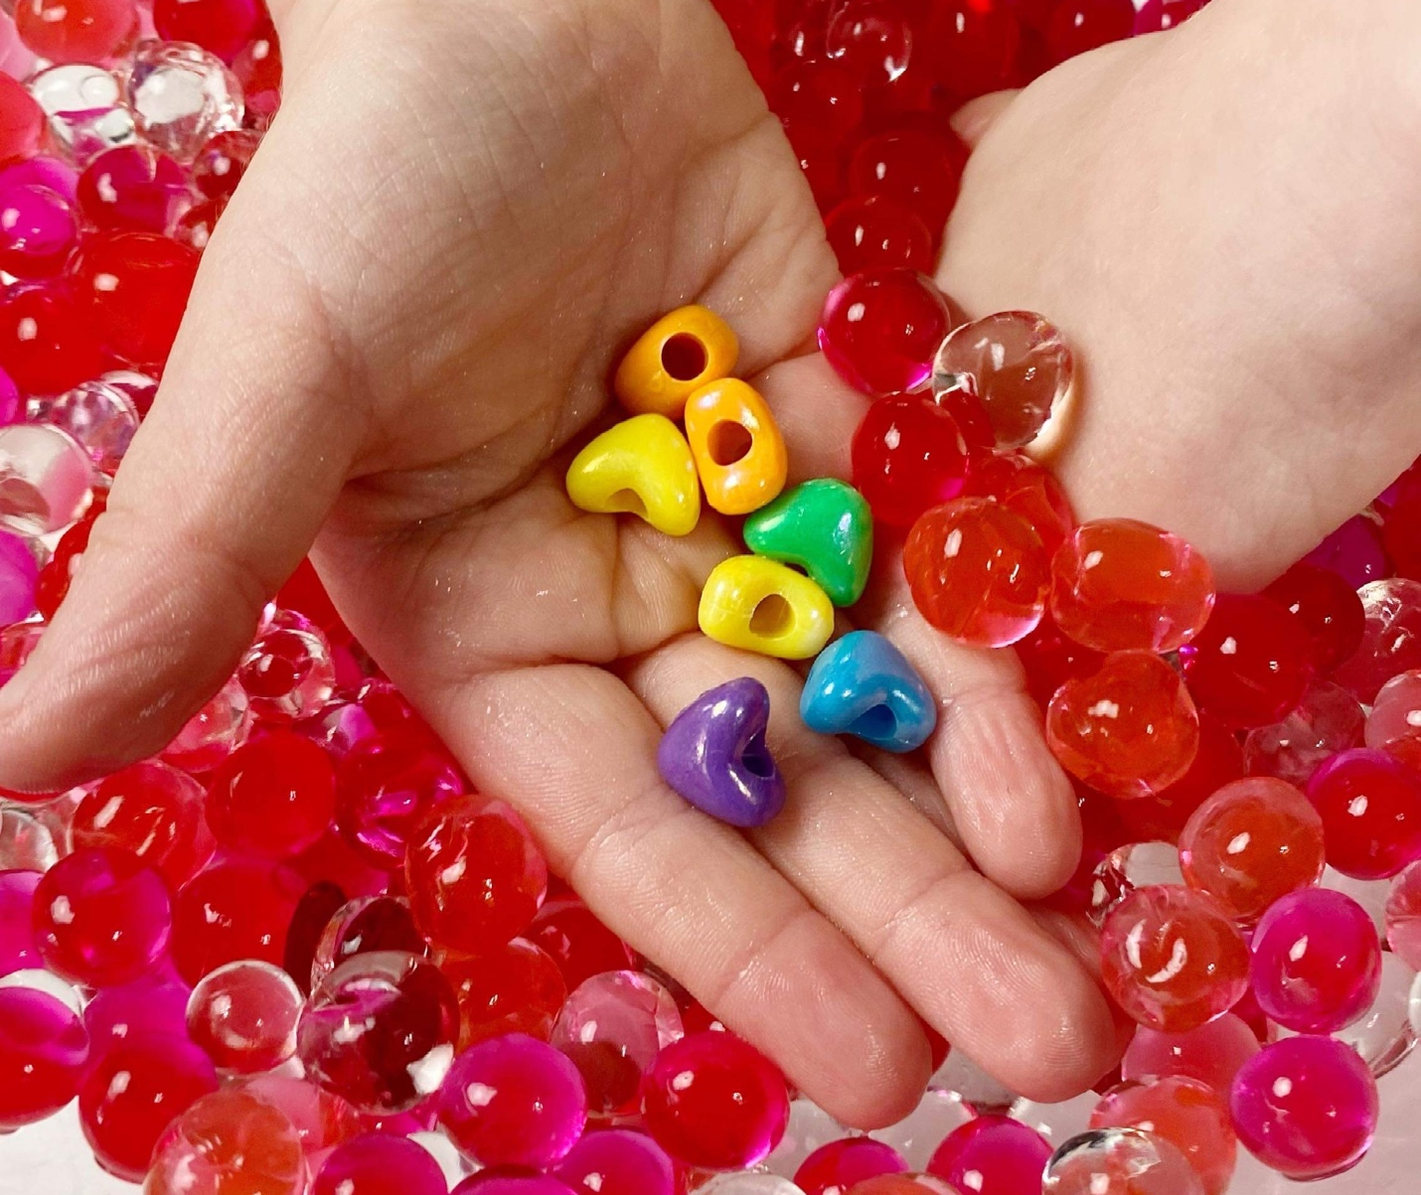
Valentine's Day is right around the corner! This is a great day to talk to your children all about love. There are so many types of love: family love, friend love, romantic love, animal love, nature love, activity love. Spark a conversation with your little to learn about their loves through the Valentine's Day Activity below!

Create a Love List!

First, let your little choose a piece of construction paper in whatever color they love the most. Then have them write words that represent all of the people and things that they love: maybe a car, a toy, a friend, a pet, a sibling, a parent, the trees, their favorite outdoor activity.
Once the words are written down, invite them to create or gather an object that represents each word. Maybe they pick a leaf from a tree outside, or draw and cut out a soccer ball, or find a picture of a friend. Then, they can glue the objects near the words.
Now they have completed their Love List and can share with you all about what they love and why! With their permission, share their Love Lists on your IG and tag @MessyPlayKits so I can see!

A Candy-Free Valentine Idea!

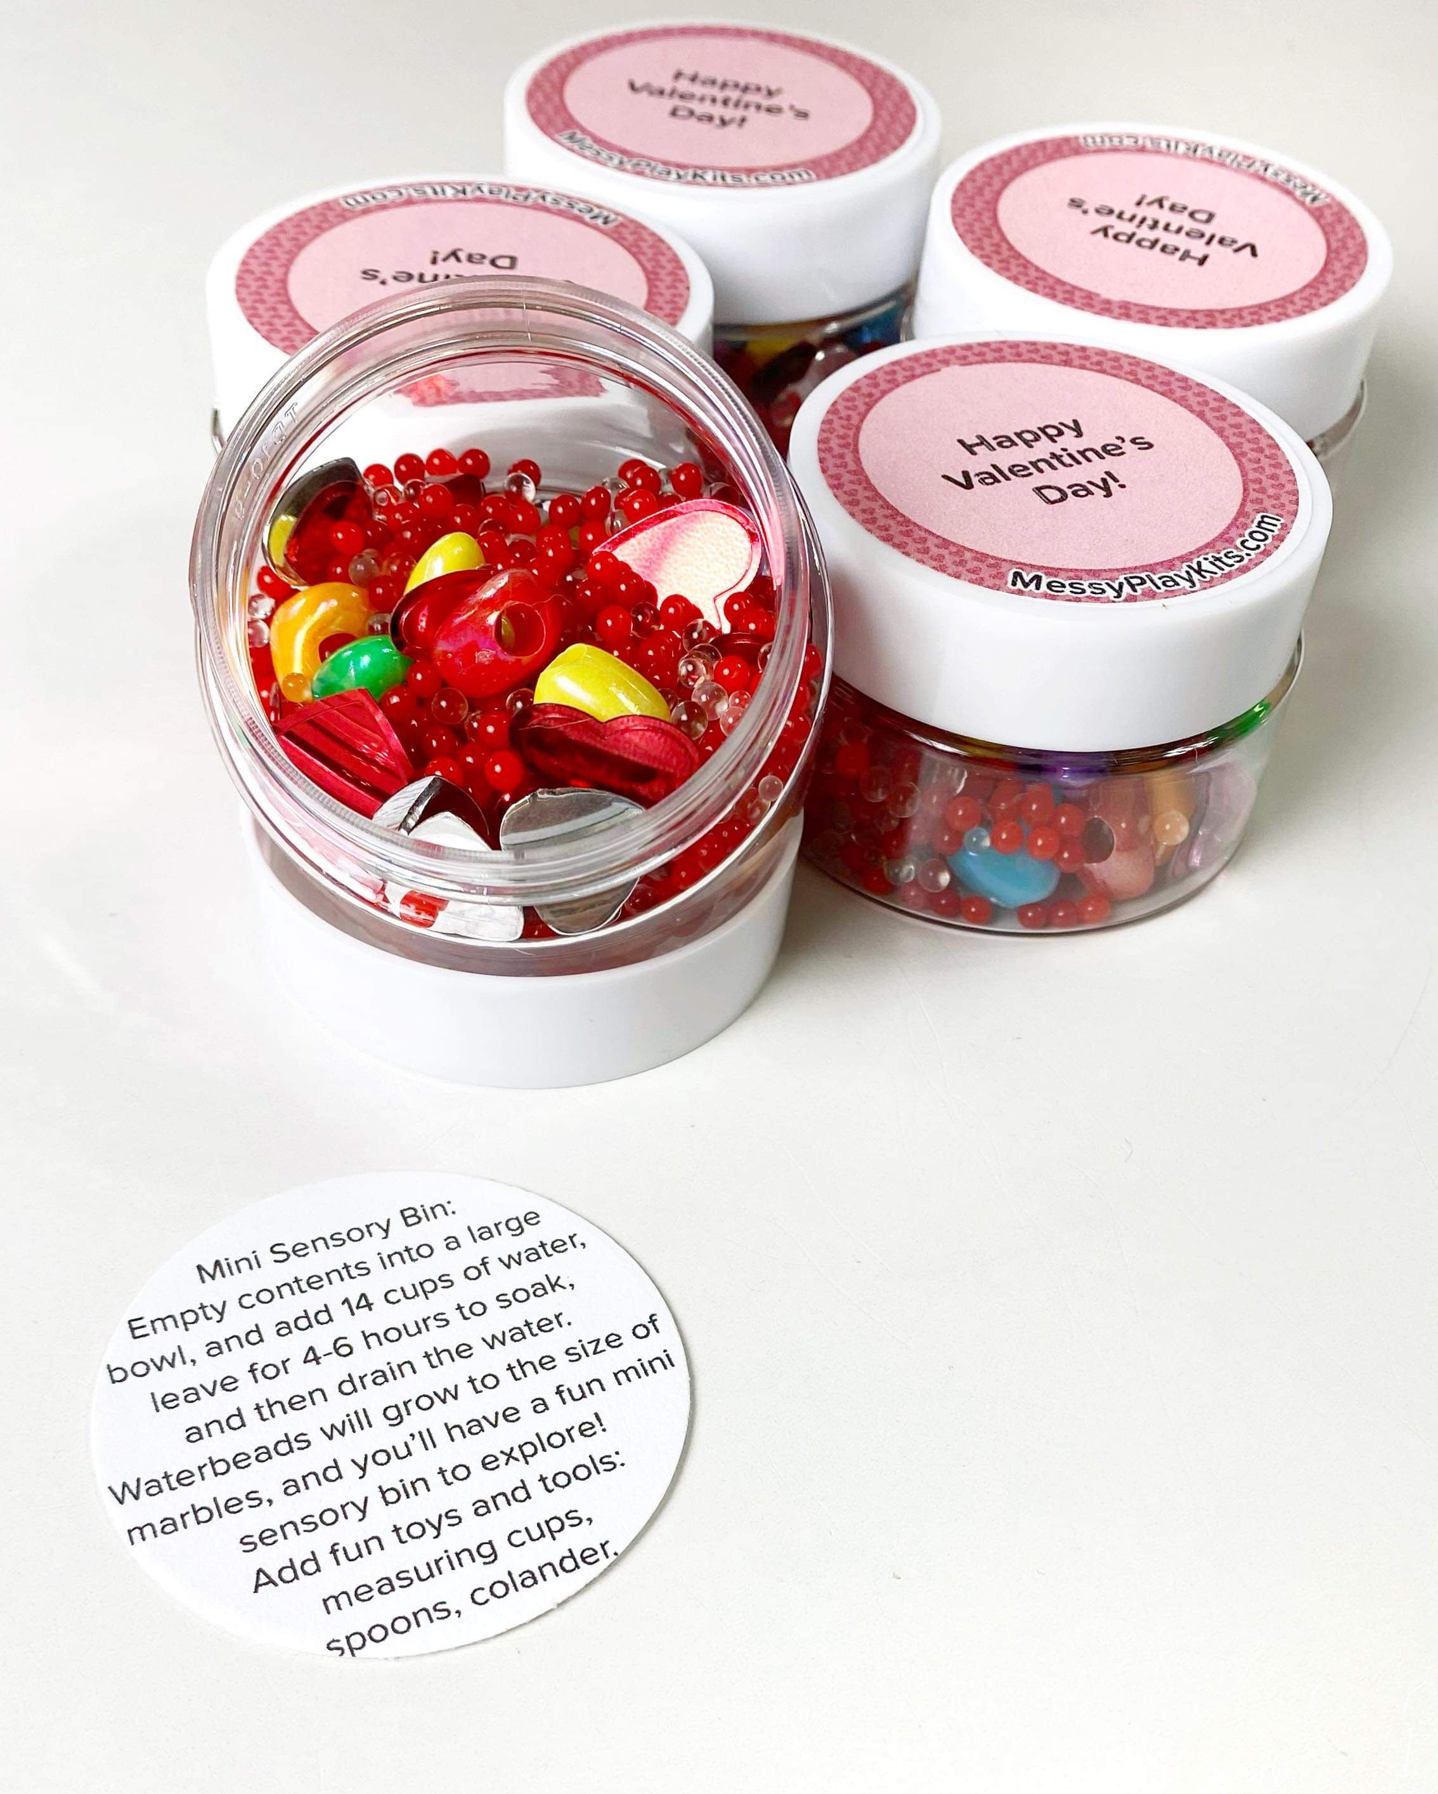
Valentine's Day Mini Sensory Bins
Sold in sets of 5, 10, 15, & 20

Shop now

Need classroom gift for Valentine's Day that's better than candy? These sensory bin mini sets come in small 1oz jars with 10g of red/pink/clear waterbeads, plus sequins, heart beads and gems, and instructions. The lids will also come with a sticker on them that you can write the gift recipient and giver's names on to make them super customizable!

Meet Us at the Library!

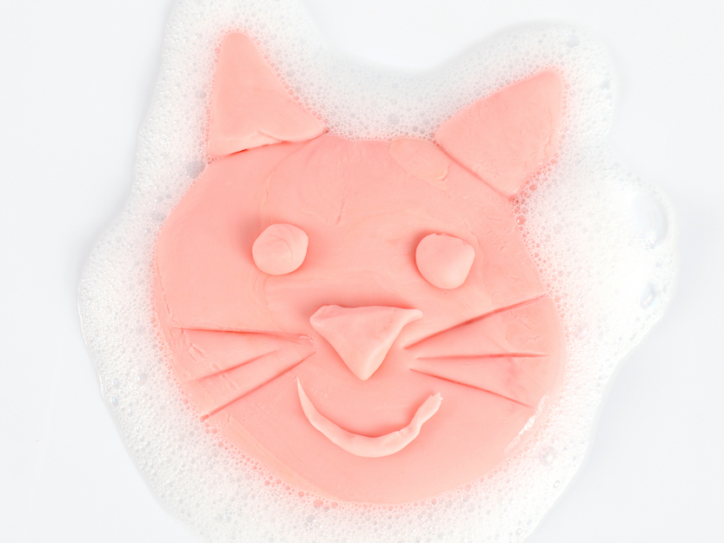
February 12: 130PM
Vineland Library
Join the MPK Team to make your very own Playdough Soap!
1450 Blossom Hill Rd
San Jose, CA 95118

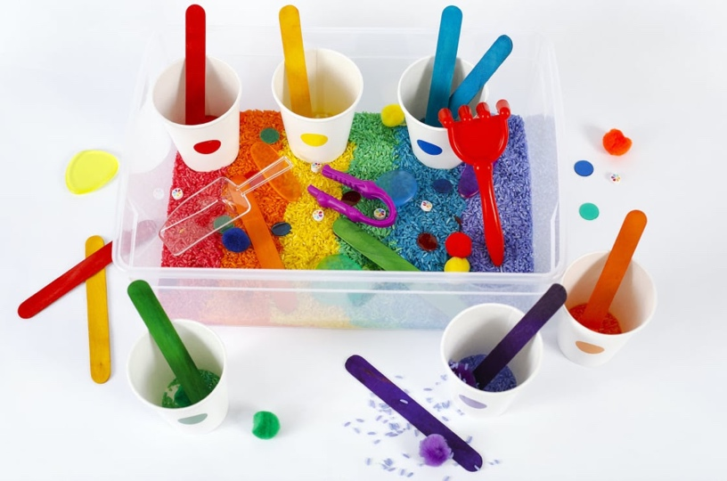
March 4: 1030AM
Educational Park
Join the MPK Team to make your very own Colored Rice Sensory Bin.
1772 Educational Park Drive
San Jose, CA 95133

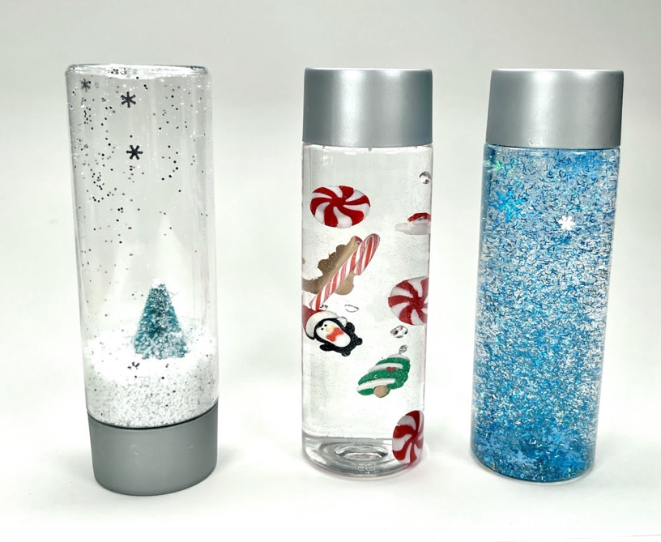
March 5: 2PM
Alviso Library
Join the MPK Team to make your very own Sensory Bottles.
5050 N First St
San Jose, CA 95002

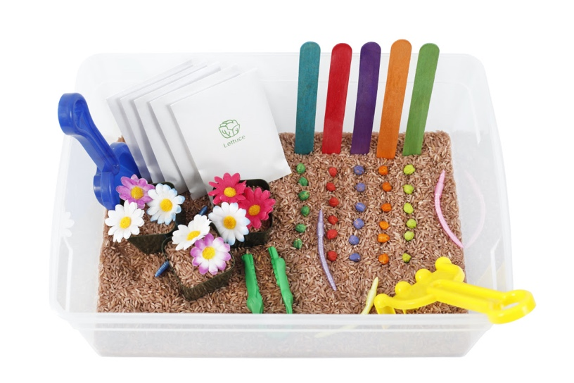
March 18: 11AM
West Valley Library
Join the MPK Team to make your very own Colored Rice Sensory Bin.
1243 San Tomas Aquino Rd
San Jose, CA 95117

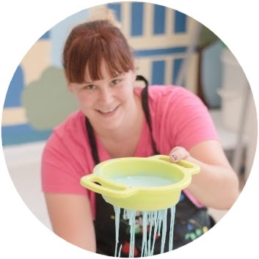
Thanks & Enjoy the Mess!
Robin Imholte
CEO and founder, Messy Play Kits
aka "Messy Play Lady"

Messy Play Kits
4 S Redwood Drive, Boulder Creek
CA 95006 United States
You received this email because you signed up on our website or at an event.
Unsubscribe

